**Terms of Reference**

**Expert group on Food Away From Home (FAFH) experiment**

**Background**

With the development of modern economies, consuming foods and beverages outside of the household’s dwelling has become common consumer behavior in the Pacific, contributing up to 15% of the total amount of dietary energy consumed in some countries like Marshall Islands and Wallis and Futuna[1]. However, the lack of adequate tools to collect information on food prepared and consumed away from home[2] (FAFH), including beverages, and of a proper method to estimate the dietary energy from these foods, have become a real challenge for data providers and analysts.

To address the issue of data collection, the Food and Agriculture Organization of the United Nations (FAO) and the World Bank (WB), in a joint document (FAO and WB, 2018) recommend that FAFH collected in Household Consumption and Expenditure Survey (HCES) be captured in a separate module, asking each household member to report on the number of meals consumed away from home by meal event (i.e., breakfast, lunch, dinner, snacks, etc.) and on the amount of money spent. Such module was developed to help respondents remember and better report on their consumption outside the dwelling, thus overcoming the issue of under-reporting observed in pre-existing methods used to capture FAFH (Farfan et al., 2019). The module was also conceived to be easy to administer.

The FAFH module was tested in 2018 through a survey experiment conducted in Marshall Islands by the Pacific Community (SPC), in collaboration with the World Bank. In the experiment, food away from home was captured through a separate module asking the main household's respondent to recall the number of meals consumed away from home by all the household members over the last 7 days by meal event, and the respective amount of money spent, as recommended in the FAO/WB guidelines. Such module on FAFH was tested against the same module filled each day by each household member under strict supervision, which was considered as the “benchmark” against which the FAO/WB module was tested. The experiment found that the number of meals reported as well as the amount spent collected through this module were very close to those reported in the “benchmark”. This was considered an improvement compared to the way food consumed away from home was previously captured in HCES of the Pacific Islands countries, where only amount spent in restaurants and bars was collected (“one line expenditure” approach). The FAFH module was therefore introduced for the first time in the Pacific in the HCES surveys conducted in Vanuatu, Marshall Islands, Kiribati and Wallis and Futuna in 2019/20. The contribution of food away from home in dietary energy in countries where new module was adopted was averaging 12% (except in Vanuatu), hence four times bigger than the contribution in countries using the “one line expenditure” approach (3%).

Despite the methodological improvement provided by the FAFH module described above, what is still unknown is: by how much the amount of Dietary Energy Consumption Away From Home (DEC_AFH) estimated from this module differs from the “true” amount of dietary energy consumed away from home. The 2018 experiment in the Marshall Islands did not have a real benchmark against which the module could be tested. As a matter of fact, neither the composition of meals nor the quantities consumed were surveyed, but only information on the number of meals. It is only in asking each respondent to report on all the products he/she consumed away from home and their quantities, that the amount of dietary energy consumed away from home can be accurately estimated. Because such information is difficult and costly to collect, alternative methods have been deployed to extrapolate DEC_AFH using information on in-house food consumption.

To date, DEC_AFH has been estimated by applying the average cost of one calorie consumed in the house to the amount of money spent to consume food away from home. This approach assumes that the composition and the price of a food basket consumed in and outside the house are very similar. To estimate the dietary energy from foods prepared and consumed away from home based on their expenditure, FAO is using the median cost of one calorie consumed in the house by area and income quintile, while the World Bank is using a flat cost with an adjustment factor to account for marketing margins and costs of running a food business.

To which extent the “true” amount of energy consumed away from home is accurately estimated through these methods, however, is still to be assessed.

To fill this methodological gap, SPC has been working on the development of a survey experiment to assess current methodologies used to estimate dietary energy sourced from FAFH among the Pacific Island countries and territories.

The objective of this experiment is twofold:

1. Test the assumption that the cost of a calorie consumed at home is the same as the cost of a calorie consumed away from home, and
2. Propose alternative and innovative ways to collect FAFH consumption.

**Design of the experiment**

The survey experiment has been designed for countries conducting a HCES according to the WB/FAO guidelines, which hence includes:

* a 7-day recall module to collect information on in-house food consumption;
* a 7-day recall module to collect number of meals consumed away from home, by meal event.

It involves two representative sub-samples of individuals (A and B), who will receive 3 modules each: one module (Module 1) to gather information on the socio-economic, geographic and demographic characteristics of each household member; one module (Module 2) to collect household in-house food consumption data; and one out of two modules (either Module 3 or 4) to collect data on food away from home consumption, with Module 4 serving as the benchmar (see graph in Annex on the description of the research design).

The experiment involves the build-up of a database including photos, recipes, weights, nutrient content and cost of the main meals available for FAFH consumption. The database will be built combining innovative techniques – such as web scrapping and crowd sourcing – and traditional methods, such as in-the-field survey on a sample of food vendors not covered by the web scraping.

**Role of the expert group**

To address the innovative aspect of some components of the experiment and to ensure its smooth running, ad hoc consultations with experts on food data collection, household survey, poverty, food security, dietary assessment, food composition and web app development will be required throughout the lifetime of the project. The group of experts will be mainly tasked to provide comments/feedback on the aspects of the experiment through a series of meeting aiming to discuss the topics listed below:

1. Introductory meeting:

This meeting, the first of the expert group, is aiming to present the experiment, the main challenges and address some questions, such as: what is missing, opportunity to test the bounded recall, enumeration plan, use of the experiment results, etc.

All members of the expert group are expected to attend.

Tentative date: *first week of July 2022*

1. Meetings on the development of the away-from-home meal database

A series of meetings will be organized to discuss the creation of the away-from-home meal database. The database will combine pictures of meals in different portions, nutrient content of the meal, place of consumption and recipe. The database will be sourced from information collected through web scraping, crowd sourcing and survey of food establishments.

* Meeting 1 - Food establishment survey

To collect pictures and weight of the meals in different portions and obtain information on the composition of the meal, a survey of restaurants/bars/work and school canteens will be conducted on a representative sub sample.

Issues to be addressed during the meeting are:

* How to best capture weighs of the meals (cook the meal or ad-hoc estimate)?
* How to conduct the restaurant survey?
* How to ensure all meals are captured?
* Meeting 2 - Development of the electronic version of the database

Issues to be addressed during the meeting are: Once the pictures are taken and the nutrient content of the meals is established what is the best way to store the information?

* + Have a pdf of pictures and an EXCEL database and link both sources using matching codes?
  + How to link pictures to nutrient values?
  + How to ensure off line access to the database?
* Meeting 3 - Crowd sourcing

To collect information on meals that are not identified through web-scraping or the food establishment survey, the experiment is planning to launch a national initiative asking people to provide information on their meal (picture, name of the meal, main composition, place of consumption, etc.)

Issues to be addressed during the meeting are:

* Should we target all meals or only traditional and street food meals?
* Development of an App or use CAPI/CAWI?
* How to reach remote populations?
* Which information to collect?
* How to filter/process the potential quantity of gathered info?

Experts in the relevant area will be encouraged to participate. These meetings will take the *2nd week of July 2022.*

1. Collection of the benchmark

Individuals selected for the experiment will be asked to fill a diary in which they will fill information on the meals they consumed away from home. The diary will be filled using PAPI and the individual will be visited each two days and information will be entered in CAPI by enumerator after checking the information.

The group will meet to discuss:

* Development of module 4
  + Do we miss something? Too many questions? Not enough? Rephrase any of them?
  + How to collect alcoholic beverages?
  + How to collect information on shared meals?
  + How to collect information on meals consumed in other’s house and not part of the atlas?
  + How to collect food consumed in ceremonies festivities, etc.?
* Tool/field work

This meeting will take place the *2nd or 3rd week of August 2022*.

1. Way forward

* Develop a database with image recognition to be further used by people to know the nutrient content of the meals they are consuming? What does it take to develop such a database?
* Develop a protocol to conduct same experiment in other regions?

This meeting will be held in *last quarter of 2022*.

**How the group will operate**

Members of the expert group will attend virtual meetings of one hour and a half each. The main topic of each meeting will be introduced through a 30-minute presentation - to expose the issue and lead the discussion - and 1-hour discussion for comments and feedback from the group.

Meeting invitations will be sent to all the members of the group, but each member can decide to attend the discussion they thinks can contribute the most and that is the most relevant to their field of expertise.

**Expected output**

* Series of recommendations /suggestions on some specific components of the project
* Active participation to the meetings

**Annex. Illustration of the survey experiment**

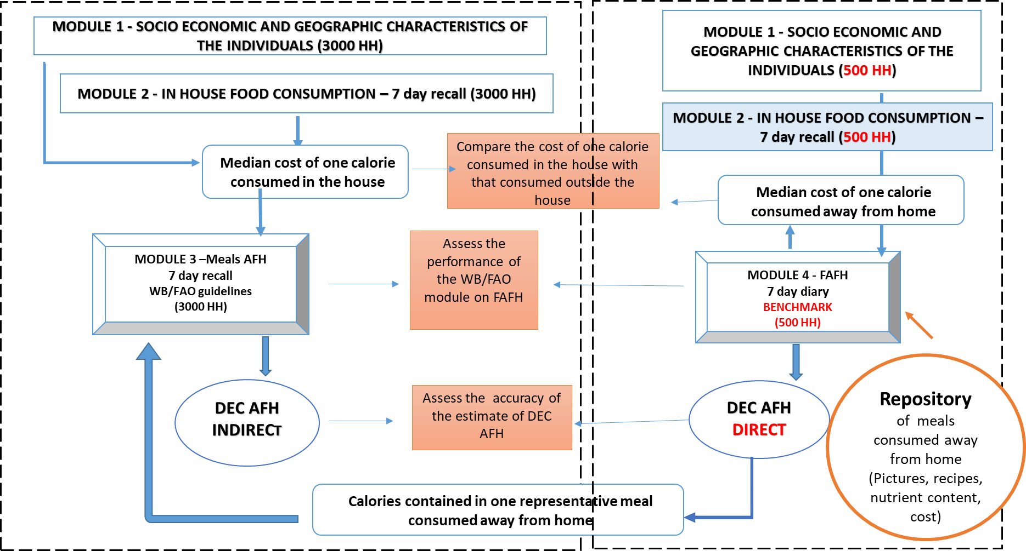

**References**

1. De Castro, J. M. (2000). Eating Behavior: Lessons From the Real World of Humans. Georgia State University, Atlanta, Georgia, USA.

2. FAO and SPC (2020). Pacific Nutrient Database User Guide. Noumea, New Caledonia

3. FAO and The World Bank (2018). Food Data Collection in Household Consumption and Expenditure Surveys. Guidelines for Low- and Middle-Income Countries. Rome. Available at: <https://openknowledge.worldbank.org/handle/10986/32503>

4. Farfan, G., McGee, K. R., Perng J. and Vaki R. (2019). Poverty Measurement in the Era of Food Away from Home: Testing Alternative Approaches in Vietnam. World Bank. Available at: <https://documents1.worldbank.org/curated/en/232581547070506208/pdf/Poverty-Measurement-in-the-Era-of-Food-Away-from-Home-Testing-Alternative-Approaches-in-Vietnam.pdf>

5. Himelein, K. (2020) Outstanding questions for the Pacific Statistics Method Board. World Bank.

6. Sharp, M. K., Buffiere B., and Menaouer, O. (2018). Household Income and Expenditure Surveys (HIES) in the Pacific region. Document prepared for the 2nd PSMB Meeting, October 2018. SPC.

7. Sharp, M. K.; Buffiere, B.; Himelein, K.; Troubat, N.; Gibson, J. Effects of Data Collection Methods on Estimated Household Consumption and Survey Costs : Evidence from an Experiment in the Marshall Islands (English). Policy Research working paper ; no. WPS 10029 Washington, D.C. : World Bank Group.

<http://documents.worldbank.org/curated/en/099834004282216747/IDU014657f420d00e042a30a68903563423f5b37>

8. Smith L.C., Dupriez, O. and Troubat, N. (2014). Assessment of the reliability and relevance of the food data collected in national household consumption and expenditure surveys. IHSN Working Paper No. 8. Available at: <http://www.ihsn.org/sites/default/files/resources/IHSN_WP008_EN.pdf>

9. SPC (2021). 8th Pacific Statistics Methods Bord Meeting – Summary Report and Outcomes. Noumea, December 2021.

10 Todd, J. E., Mancino, L., and Lin, B. H. (2010). The impact of food away from home on adult diet quality. USDA.

11 Troubat, N. and Sharp, M.K. (2021). Food consumption in Kiribati – Based on analysis of the 2019/20 Household Income and Expenditure Survey. Tarawa, FAO and SPC. Available at: <https://doi.org/10.4060/cb6579en>

12. Troubat, N. and Sharp, M.K. (2021). Food consumption in the Marshall Islands – Based on analysis of the 2019/20 Household Income and Expenditure Survey. Majuro, FAO and SPC. Available at: <https://doi.org/10.4060/cb7583en>

13. Troubat, N., Faaola, E. and Aliyeva, R. (2020). Food security and food consumption in Samoa – Based on the analysis of the 2018 Household Income and Expenditure Survey. Apia, FAO and SBS. Available at: <https://doi.org/10.4060/cb0613e>

14. Troubat, N., Sharp, M.K. and Andrew, N.L. (2021). Food consumption in Solomon Islands – Based on the analysis of the 2012/13 Household Income and Expenditure survey. Honiara, FAO and SPC. <https://doi.org/10.4060/cb4459e>

15. Troubat, N., Sharp, M.K. and Andrew, N.L. (2021). Food consumption in Solomon Islands – Based on the analysis of the 2012/13 Household Income and Expenditure survey. Honiara, FAO and SPC. <https://doi.org/10.4060/cb4459e>

1. Assessment based on the analysis of food data collected in 9 HIES conducted in the pacific between 2012 and 2021.
2. The term “food consumed away from home” encompasses prepared foods bought and consumed outside the house, but excluding prepared foods bought and consumed in the house and foods prepared in the house and consumed away from home.